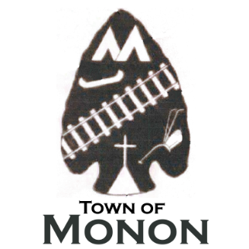**TOWN OF MONON**

800 N Adams ST. – PO Box 657 – Monon, IN 47959

219-253-6441

**GOLF CART REGISTRATION FORM**

**Golf Cart Registration, Requirements and Restrictions are regulated under Town Code:**

[Ordinance # 2024-11](https://www.townofmonon.com/documents/43/2024-11_GOLF_CARTS.pdf)

Owner Name:

Phone:

Street Address:

Golf Cart ID #:

Color:

Insurance Carrier:

Policy #:

Registration valid from January 1 to December 31 of each registration year.

STICKER #

Staff:

Receipt #: Proof of Insurance (COI): ID # Add to log: