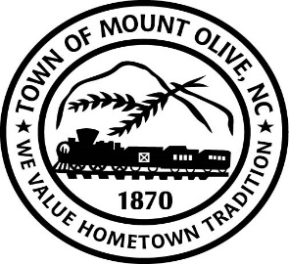
REGULAR BOARD MEETING AGENDA
MONDAY, APRIL 12, 2021
114 EAST JAMES STREET
7:00 P.M.
I. CALL TO ORDER -
Invocation
Pledge of Allegiance – Boy Scout Flores
II. ROLL CALL –
III. READ CONFLICT OF INTEREST STATEMENT -
In accordance with the State Government Ethics Act, it is the duty of every
Member of the Mount Olive Board of Commissioners to avoid both conflicts of interest and appearances of conflict.

Does any member of the Board of Commissioners have any known conflict of interest or appearance of conflict with respect to any matters coming before the Board of Commissioners today?

If so, please identify the conflict or appearance of conflict and refrain from
any undue participation in the particular matter involved.

IV. APPROVAL OF PUBLISHED AGENDA (*Motion/Second-Roll Call)

V. APPROVAL OF MINUTES (*Motion/Second-Roll Call)
a. March 1, 2021 Meeting.

VI. PUBLIC FORUM
Speakers must state name, address, phone number and hold comments to maximum of three minutes.

VII. ACTION MEMOS (*Motion/Second-Roll Call)

04-16 –
Consider Approval of the Following Properties to Declare Them a Public Health Nuisance:
- 317-319 Oliver Street
- 418 East Nelson Street
04-17 – Consider Approval of Resolution Authorizing Mayor Kenneth Talton as Certified Official ,Project Budget Ordinance and Authorizing Execution of Grant Documents for CDBG Neighborhood Revitalization Grant Number 19-C-3131 in the amount of $750,000.00.
04-18 – Consider Approval of Police Citizen Advisory Committee
A.N. Martin
Steve Martin
Latashia Williams
Sean Simpson
Sam Platt
Mary Denning

04-19 –
Consider Approval of Resolution in Support of the NC Pickle Festival 2021
04-21 – Consider Approval of Resolution to Approve of Engagement Letter and Audit Contract for S. Preston Douglas & Associates, LLP.
04-22 – Consider Approval of Resolution Regarding State Retention Policy (Link is listed below)
https://archives.ncdcr.gov/media/807/open
04-23 – Attorney Carroll Turner will present a petition requesting annexation of real property for location of Tractor Supply Company
04-24 – Attorney Carroll Turner will present a petition for annexation of real property belonging to Danny & Tammy Keel.
IX. TOWN MANAGER’S REPORT
X. MAYOR AND BOARD OF COMMISSIONERS REPORTS

ADJOURN

