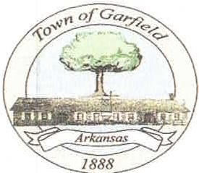

03/03/2023

P.O. BOX 131
Garfield, AR 72732
(479) 359-3652 • Fax (479) 359-2345

At the March 14, 2023, Garfield City Council meeting, organizers will solicit input, and answer questions about a proposed Pre-K through 5th grade Charter School. The proposed location would include the existing Elementary School campus owned by the Rogers Public School System, in Garfield. The Rogers School Board voted to close the school, at the end of the 2023 - 2024 school year.

The proposed Charter School, tentatively referred to as Garfield Scholar's Academy, will be an inclusive and innovative learning solution for the Garfield community. VVhen we open our doors in the Fall of 2024, our School will continue the history of being the longest continually operating Elementary School in the State of Arkansas. We intend to provide an opportunity rich environment fostering the development of successful, life-long learners with deep community involvement. We recognize that each child and family is unique. Therefore, we will tailor a learning plan for each scholar based on their academic needs. Our services will include, but are not limited to, in-class/in-person instruction, hands-on learning experiences, community involved learning, technology enhanced learning, one-to-one technology, special education, counseling and a free/reduced lunch program. The Garfield Scholar's Academy will exist to serve Garfield and neighboring communities with a traditional curriculum that is focused on engaging students in their learning, while building personal character, and ensures the success of all learners.

The City Council Meeting is scheduled for 6:00 p.m. at 14655 South Wimpy Jones Road, City Hall, in Hamilton Park. The public is invited to attend.
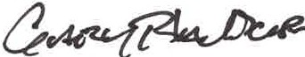
Gary Blackburn
Mayor, Garfield Arkansas

