

**Melody Kwok**

Benton County Communications Director

**P:** (479) 268-9263 **C:** (479) 721-3364

**E:** Melody.Kwok@bentoncountyar.gov

**FOR IMMEDIATE RELEASE**

Benton County provides update on disaster relief – 6.4.23

FEMA and the U.S. Small Business Administration are accepting applications for federal disaster funds.

[**relief.bentoncountyar.gov**](https://relief.bentoncountyar.gov/)

##### **New Update- National Guard Extension**

The National Guard Mission for Benton County has been extended through Friday, June 21. Guardsmen will help with traffic control at the three Benton County Debris Drop Sites.

##### **New Update- County Assessor and Collector**

The servers for the Benton County Assessor and Collector are now operational. Online services have resumed for personal property and business assessments. Payments can be made to the Collector for personal property taxes. Due to storm damage, the Benton County Rogers Office will remain closed until further notice. The Bentonville, Gravette, and Siloam Springs Satellite Offices are still closed.

Governor Sarah Sanders signed an [executive order](https://governor.arkansas.gov/news_post/sanders-signs-an-executive-order-to-provide-relief-pursuant-to-the-emergency-declared-in-executive-order-24-07/) allowing Benton County and other storm-affected counties to suspend the 10% penalties for a late personal property or business assessment until June 30, 2024. The original deadline was May 31, 2024.

**New Update- Damage Assessments**

The Benton County Division of Public Safety has vetted 2,026 damage reports from the Citizen Damage Reporter. These reports include buildings within and outside city limits. Of the 2,026 vetted damage reports, we have had:

* + 78 Destroyed – House has extensive damage to 2 or more walls/roof
  + 298 Major Damage – Extensive damage to a least 1 wall/roof
  + 754 Minor Damage – Roof or wall penetrated by debris
  + 709 Affected – fences, trees, cars, hail damage to the home but no structural damage

##### **New Update- Benton County Debris Cleanup**

The Benton County Debris Sites have collected 818 loads of vegetative debris as of Monday, June 3rd. Starting tomorrow, **Wednesday, June 5**, the **Benton County Decatur Road Yard will accept construction and demolition debris (C&D)**. C&D debris includes, but is not limited to, siding, fencing, furniture, drywall, roofing, etc. C&D debris DOES NOT include appliances or hazardous materials. The Decatur Road Yard will be the only Benton County maintained site to accept C&D debris. Mixed loads of debris will not be accepted. Vegetative and C&D debris loads must be separated. The other two sites, Hwy 62 East Side and the Benton County Fairgrounds, will only accept vegetative debris.

All three sites are open **Monday – Saturday** from **7 AM – 7 PM**. Please be aware that if there is lightning in the area, we will suspend operations at the debris sites.

The Benton County East Side Debris Dropoff site is located at [603 S Hwy 62, Rogers](https://maps.app.goo.gl/3wA9JP8uE5CcRMVP9). Please look for signage to find this site. The Benton County Fairgrounds North Parking Lot entrance is located off Hwy 279/S Vaughn Road. The Benton County Decatur Road Yard is located at 200 Spavinaw Ave.

The Benton County Debris Drop Sites are for the public only. Commercial businesses will need to find alternative arrangements for their debris disposal.

##### **Benton County Debris Cleanup Maps**

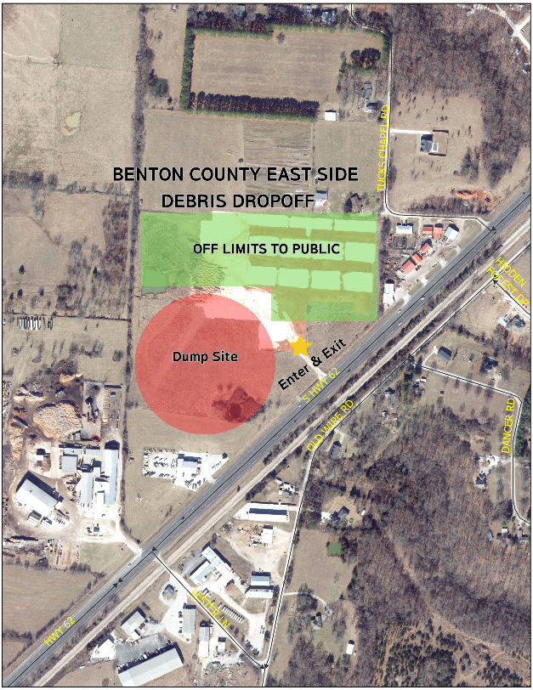

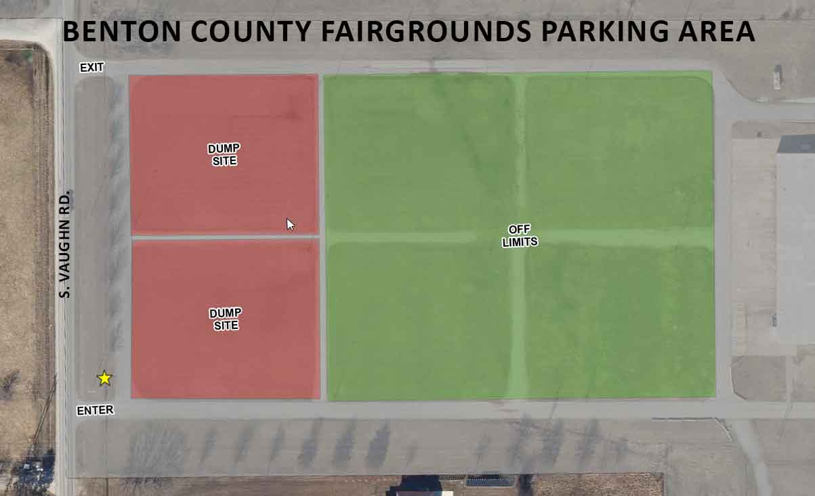

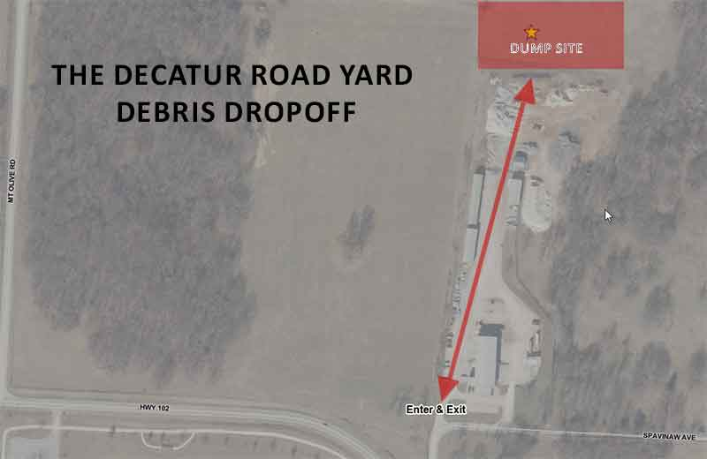

**Relief Information Recap**

##### **SBA Business Recovery Center**

##### The U.S. Small Business Administration opened a Business Recovery Center at the World Trade Center in Rogers. At the center, people can apply for low-interest federal disaster loans.

Where: World Trade Center 3300 S Market St, Suite 400, Rogers

Hours: Mondays- Fridays 8A - 5P & Saturdays 8A - 1P

##### Loans are available to businesses of all sizes, private nonprofit organizations, and homeowners. Please review the U.S. Small Business Administration (SBA) letters for more information.

##### [English](chrome-extension://efaidnbmnnnibpcajpcglclefindmkaj/https:/relief.bentoncountyar.gov/assets/SBA%20Assistance%20English.pdf)

##### [Spanish](chrome-extension://efaidnbmnnnibpcajpcglclefindmkaj/https:/relief.bentoncountyar.gov/assets/SBA%20Assistance%20Spanish.pdf)

##### Please visit [sba.gov/disaster](https://www.sba.gov/funding-programs/disaster-assistance) to apply for SBA assistance online.

##### **FEMA**

##### The Federal Government has approved a request for a Major Disaster Declaration in Benton County.

**Apply for FEMA Assistance**

* Apply online at: <https://www.disasterassistance.gov/>
* Call the FEMA Helpline at 800-621-3362
* An in-person FEMA Disaster Recovery Center is coming to Benton County.

If you have insurance (such as flood, homeowners, renters, auto, or other types of insurance), please file a claim with your insurance provider as soon as possible. You do not have to file your claim prior to applying for FEMA disaster assistance, but you will be required to provide FEMA with your insurance settlement or denial before being considered for certain types of assistance.

* Take photos of your damaged home and belongings for your own records.
* Make a list of damaged/lost items, which may be helpful when working with your insurance or discussing your losses with a FEMA inspector.

##### **Community Resources**

Downloadable flyers are available in English and Spanish. We ask that community groups pass these flyers out to help those who may not have access to the Internet.

Benton County and Hark at Excellerate Foundation have compiled a list of community resources offered to those affected by the storms. The downloadable Excel spreadsheet can be found on the [Benton County Relief](https://relief.bentoncountyar.gov/) website. The spreadsheet is updated regularly with new information.

##### **Beware of Scams**

The Benton County Sheriff’s Office and Benton County Prosecutor’s Office want to ensure your safety and security, so we're issuing this important warning about potential scams.

[A message from Benton County Sheriff Shawn Holloway](https://vimeo.com/manage/videos/952458991)

##### **Benton County Facilities Closures**

The following Benton County facilities will be closed until further notice:

* Benton County Rogers Office – 2109-2117 W Walnut St, Rogers
* Circuit Court Division V Judge Xollie Duncan – 102 Northeast “A” St, Bentonville
* Assessor & Collector Bentonville Satellite Office – 2401 SW D Street, Bentonville
* Assessor & Collector Gravette Satellite Office – 901 1st Ave SW, Gravette
* Assessor & Collector Siloam Springs Satellite Office – 707 Lincoln St, Siloam Springs