**Melody Kwok**

Benton County Communications Director

**P:** (479) 268-9263 **C:** (479) 721-3364

**E:** [Melody.Kwok@bentoncountyar.gov](mailto:Melody.Kwok@bentoncountyar.gov)

**F OR I M M E D IA TE R EL E A SE**

Benton County provides an update on disaster relief

According to the National Weather Service, seven confirmed tornados and strong winds damaged property in Benton County on May 26.

# Benton County Disaster Relief

Benton County has compiled all disaster relief information into [one website](https://relief.bentoncountyar.gov/). We encour- age people to visit this site for information on how to report structural damage, debris re- moval, community resources, and county facility closures. This website will be regularly updated with new information. Please check this site frequently for updates.

# Suspended Personal Property Assessment Deadline

Today, Governor Sarah Sanders signed an [executive order](https://governor.arkansas.gov/news_post/sanders-signs-an-executive-order-to-provide-relief-pursuant-to-the-emergency-declared-in-executive-order-24-07/) allowing Benton County and other storm-affected counties to suspend the 10% penalties for a late personal property or business assessment until June 30, 2024. The original deadline was May 31, 2024.

# Community Resources

Two flyers, available in English and Spanish, have been newly added to the Disaster Relief Community Resources section. These downloadable resources detail how to sep- arate debris piles, debris public sites, debris pickup removal, and the Citizen Damage Reporter. We ask that community groups pass these flyers out to help those who may not have access to the Internet.

Benton County and Hark at Excellerate Foundation have compiled a list of community resources offered to those affected by the storms. The downloadable Excel spreadsheet can be found on the [Benton County Relief](https://relief.bentoncountyar.gov/) website. The spreadsheet is updated regu- larly with new information.

# Benton County Debris Cleanup

Benton County will have **three** debris dump sites available for public vegetative debris disposal starting at **7 AM** on **Friday, May 30**.

The Benton County East Side Debris Dropoff site, located at [603 S Hwy 62, Rogers](https://maps.app.goo.gl/3wA9JP8uE5CcRMVP9), will be open to the public for vegetative debris drop-off from **7 AM to 7 PM**, **Monday – Sat- urday,** until further notice. The dump site entrance is along US HWY 62. When driving from Rogers, the entrance is on your left, past the intersection of Cemetery Road and US HWY 62. Please look for signage to find this site.

The Benton County Fairgrounds North Parking Lot, located off Hwy 279/S Vaughn Road, will be open to the public for vegetative debris drop-off from 7 AM to 7 PM, Mon- day through Saturday, until further notice.

The Benton County Decatur Road Yard, located at 200 Spavinaw Ave, will be open to the public for vegetative debris drop-off starting on **Thursday, May 30,** from **7 AM to 7 PM, Monday – Saturday** until further notice.

The public can bring vegetative debris to these drop sites, including root balls, logs, tree branches, leaves, and brush. No other debris will be accepted at this time. Construction and demolition (C&D) debris will not be accepted. C&D debris includes, but is not lim- ited to, roofing, fences, drywall, furniture, etc. Mixed loads of debris will not be accepted. These sites are for public use only. The Benton County Debris Drop Site is for the public only. Commercial businesses will need to find alternative arrangements for their debris disposal.

# Benton County Debris Cleanup Maps

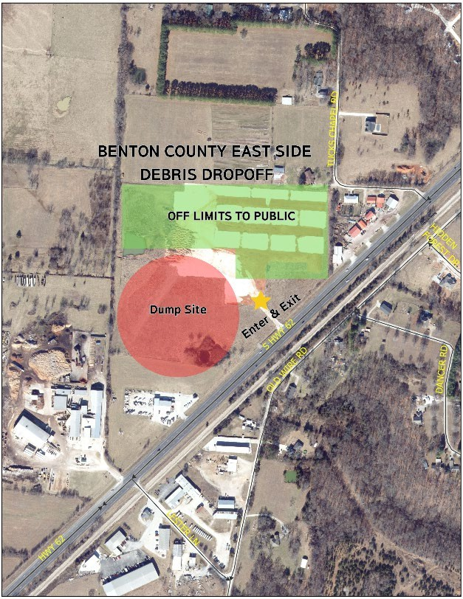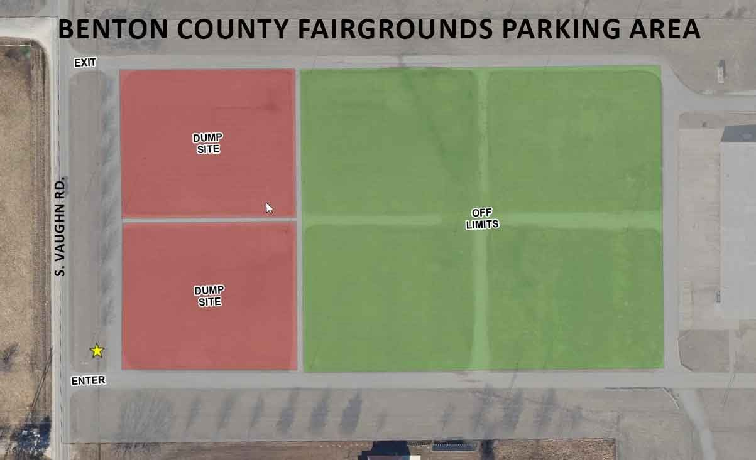

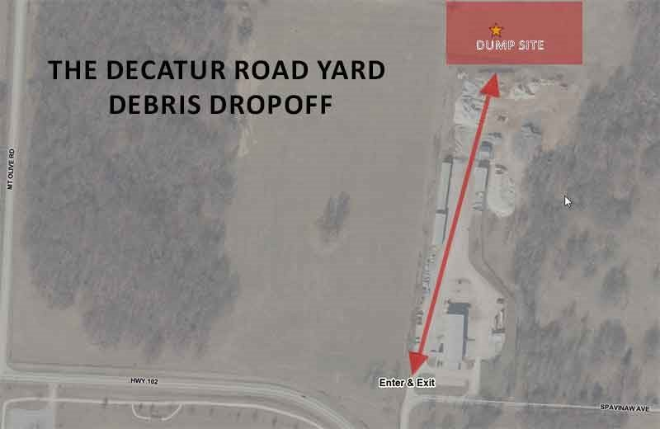

**Report Home Damage**

Benton County Division of Public Safety requests residents report personal property structural damage from the May 26 storm through the [Benton County Citizen Damage](https://report-ar-benton.orioncentral.com/?fbclid=IwZXh0bgNhZW0CMTAAAR2qm7BDct5WAhQXjkIQzklHMe5XxNX2sIENnbaHEbXZf-_N2LduD_ZTQ3Q_aem_Ac_RZHtDUMJgQ4eezRuQIM1oe6SaI9POIp2So0XOZ0iO5Wxx7TbmtiovGZfHKzQAvyAdP1q2frvOzyMc6q6rO8iL) [Reporter](https://report-ar-benton.orioncentral.com/?fbclid=IwZXh0bgNhZW0CMTAAAR2qm7BDct5WAhQXjkIQzklHMe5XxNX2sIENnbaHEbXZf-_N2LduD_ZTQ3Q_aem_Ac_RZHtDUMJgQ4eezRuQIM1oe6SaI9POIp2So0XOZ0iO5Wxx7TbmtiovGZfHKzQAvyAdP1q2frvOzyMc6q6rO8iL). The Citizen Damage Reporter is a portal where citizens can enter their esti- mated personal property structural damage.

Individuals should only report damage if debris, such as trees, has punctured their homes. Benton County will need clear photos of the damage done to the home itself. All reports sent in will be reviewed by the Division of Public Safety and used for disaster declaration purposes.

Benton County needs damage report information, as it will assist us with information the State and FEMA need to determine if Individual Assistance (IA) will be available. Indi- vidual Assistance (IA) is to assist individuals with uninsured losses to their homes. It does not help with vehicular damage, downed trees, or fences; it is strictly for a person’s residential structure only.

The damage report information will only be shared with the State of Arkansas and FEMA for these purposes. If IA becomes available, we will reach out to the individuals and let them know the steps for applying for IA through the State and/or FEMA. Gover- nor Sarah Sanders has declared a disaster declaration for Benton County.

If Benton County attains a presidential disaster declaration, then citizens may be eligible for federal assistance through FEMA. More details will be released for residents if a fed- eral disaster declaration is made.

# Benton County Facilities Closures

The following Benton County facilities will be closed until further notice:

* Benton County Rogers Office – 2109-2117 W Walnut St, Rogers
* Circuit Court Division V Judge Xollie Duncan – 102 Northeast “A” St, Bentonville
* Assessor & Collector Bentonville Satellite Office – 2401 SW D Street, Bentonville
* Assessor & Collector Gravette Satellite Office – 901 1st Ave SW, Gravette
* Assessor & Collector Siloam Springs Satellite Office – 707 Lincoln St, Siloam Springs

Circuit Court Division IV Judge John R. Scott will reopen on Monday, June 3.