HUNTSVILLE TOWN CONSOLIDATED FEE SCHEDULE
Effective July 1, 2020 (updated 03-21-2024)

CEMETERY

**No cemetery plots will be sold to anyone living outside the 84317-zip code area without approval from the Huntsville Town Council. Interment fees for those living outside of the 84317 zip code area who purchased plots prior to April 19, 2018 will be the same as the Non-resident fee.

Plots (84317 – Non-Resident) - $ 1500
Plots (Huntsville Town) - $ 500
Interment (84317 – Non-Resident) - $ 700
Interment (Huntsville Town) - $ 500
Weekend Interment (84317- Non-Resident) - $900
Weekend Interment (Huntsville Town) - $700
Cremation Interment (84317 – Non-Resident) - $ 300
Cremation Interment (Huntsville Town) - $ 200
Weekend Cremation Interment (84317- Non-Resident) - $400
Weekend Cremation Interment (Huntsville Town) - $300
Infant Interment (84317 – Non-Resident) - $ 300
Infant Interment (Huntsville Town) - $ 200
Weekend Infant Interment (84317- Non-Resident) $400
Weekend Infant Interment (Huntsville Town)- $300
Disinterment, full - $ 2000
Disinterment, Urn - $600
Weekend Disinterment, full- $2200
Weekend Disinterment, Urn- $800
Plot Buy Back - $ 400

WATER/GARBAGE

Base rate allots 7,000 gallons per month

Huntsville Town Rates:

Garbage - $ 22
Extra Garbage Can - $ 22
Commercial Garbage Can - $ 27

Base Rates: Users of the Huntsville Town culinary system shall be assessed a monthly base rate according to the respective meter size and category of their connection(s) as defined in Table 1:
Table 1 - Base Rates
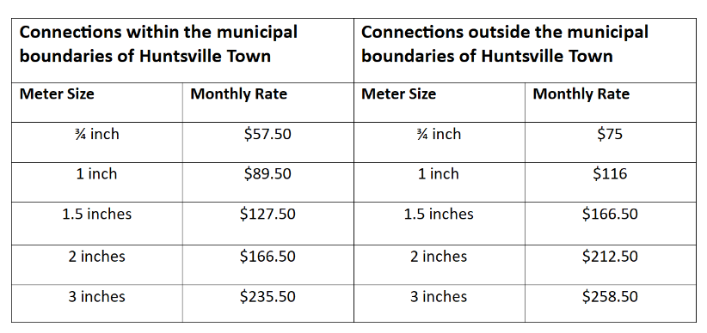

Overage Fees: Users of the Huntsville Town culinary system shall be assessed an additional monthly fee that if they exceed 7,000 gallons per month per connection. The rate at which the overage fee shall be assessed shall be based on the overage category of their usage as defined in Table 2:

Table 2 – Overage Fees
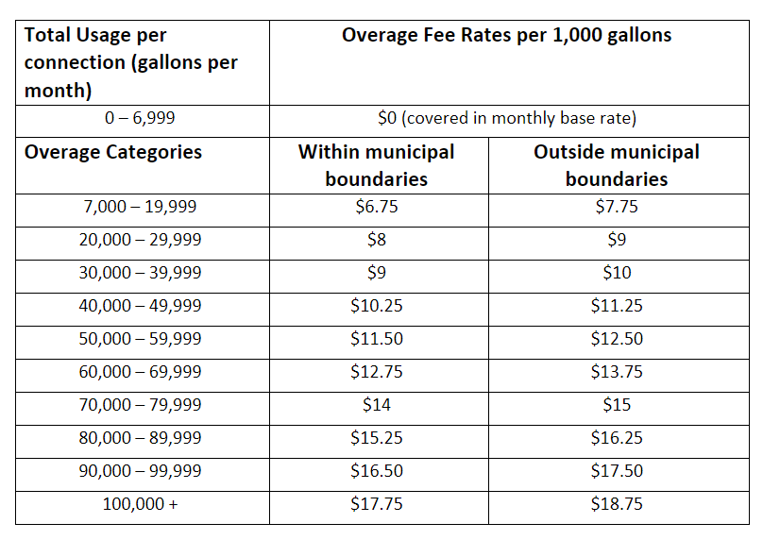

Late Fee – 1 ½% of the total bill
Certified Letter Fee - $ 15
Return Check Fee - $ 30
Shut Off Fee - $ 75
Water Reconnect Fee - $ 75

Culinary Water Connection Fee (Huntsville Town) - $ 7,500
Culinary Water Connection Fee (Out of Town) - $ 30,000
Culinary Water Meter Fee ( 3/4” meter*) - $ 350
Culinary Water Connection Fees (provide for 30 feet of ¾” at cost of)- $ 350 Property Owner will pay the cost of connection beyond 30 feet of ¾” pipe*.
Fire Hydrant - $ 20,000
Water Fees for Construction or Companies - $ 50 per 1,000 gallons and $ 25 for each additional 1,000 gallons
*Larger meters will require an additional charge please contact the Town office for pricing

Huntsville Waterworks (Private Company – Not a Huntsville Town Fee)
Waterworks Irrigation Co. Connection Fee - $ 1000 minimum
Waterworks Irrigation Co. Purchase Shares (2 required) - $ 500 each = $1,000
Water Irrigation Co. Water Shares Yearly Assessment Fee - $ 60 per share

PARKS

East/West Bowery & Stage Rental:

Valley Resident Half Day - $ 50
Non-Resident Half Day - $ 85
Valley Resident Full Day - $ 100
Non-Resident Full Day - $ 170

Special Events:

Activities held on Town streets or Town property are defined as "special events" when they are an athletic, entertainment, or political activity held for profit, nonprofit, or charitable purposes with the anticipated number of participants plus spectators exceeding 150, or any event/gathering requiring alteration of Town traffic/closing of a Town street.

Fees for Special Events are based on the number of people attending and participating in the event. The event must receive Town Council approval.
150-300 people: $ 1000 for park rental with a $ 250 refundable cleaning fee

201-500 people: $ 2000 for park rental with a $ 500 refundable cleaning fee

501 and above: $ 3500 for park rental with at $ 750 refundable cleaning fee

BUSINESS LICENSING
Home Occupation Business License (licenses not required) - $ 36
Commercial Business License - $ 75
Restaurant - $ 100
Peddlers/Solicitors - $ 25 per person for two-week license
Beer License - $ 250

OTHER FEES
Green Waste (for Huntsville Residents Only):
Per load - $ 5
Punch Pass (5 loads) - $ 20

GRAMA Requests:
Research - $ 20 per hour
Copies - .25
Audiovisual Reproduction - $ 10 per item

Copies: .25 per page
Audiovisual Copies: $ 10 per item

LAND USE

Land Use Permit – $ 150
Conditional Use Permit: $ 450
Variance Application: $ 450
Subdivision Application: $ 750 + $25 per lot
Minor Subdivision Application: $ 300 + $ 25 per lot
Boundary Line Application: $ 300
Consolidation Application: $ 150
Land Use/Engineering Research: $ 170 per hour
Zoning Map Amendment: $ 500
Annexation Application: $ 2000

BUILDING PERMIT

Plan Reviews, Valuations and Building Permits based on current ICC tables – see attached.

Electrical, Plumbing and Mechanical inspections associated with a Building Permit – each individual inspection is 5% of the Building Permit.

Building Permits also require Wastewater Certificate and Fire District Receipts from Weber County.

Self-Remodel Permit - $ 0
Excavation Permit - $ 75
Individual inspection - $ 200
Replace & Rework Permit - $30

**Penalty for not obtaining a building permit – 5% of the value of the project up to $ 7,500

