FOR IMMEDIATE RELEASE

October 7, 2024

Boone Hearts Boone: Boone County, IN Supports Boone, NC Following Devastation from Hurricane Helene

Boone County, IN – After the recent devastation caused by Hurricane Helene, the community of Boone, North Carolina, finds itself facing a multifaceted crisis. Known for its thriving tourism economy—especially during the fall season with its brilliant foliage and popular area events like the Woolly Worm Festival—Boone’s recovery is being hindered by the cancellation of these key attractions. With roads inaccessible and visitors unable to reach the region, an already economically struggling area now faces additional challenges.

This year was meant to be a strong season for the area, with the Woolly Worm Festival, a festival in the local Boone region, having been featured on CBS Mornings with Jane Pauley. The festivals and the seasonal tourism around the fall leaves create income that residents live on for months. With that income gone, the economic impact of the flooding from Hurricane Helene is compounded with the coming winter and lack of income. <https://www.youtube.com/watch?v=4-GzAPMkBY4>

“We want to help our partners in tourism,” says Discover Boone County Executive Director, Allyson Gutwein. “The gravity of the situation they are facing is dire. Their community is much like ours, comprised of charming shops and businesses run by hardworking individuals. We know that if this devastation had hit our area we would need help. We are going to step up to help those in Boone, NC as a gesture of solidarity in hospitality, business and tourism.”

To help Boone, NC, during this critical time, Boone County, IN, is stepping up through the Boone Hearts Boone initiative. With winter rapidly approaching in the mountainous areas of North Carolina, this campaign is focused on collecting essential winter items for those affected by the hurricane’s devastation.

"We are collecting hats, gloves, scarves, socks—in sizes from infant to adult 5X—to ensure everyone has the warmth they need for the harsh winter months. We will also accept blankets and sleeping bags to provide additional comfort and protection," stated Gutwein.

Items can be donated in two ways:

Drop them off at one of the designated collection points throughout Boone County, IN. These collection points can be found here: [www.discoverboonecounty.com](http://www.discoverboonecounty.com)

Send them directly to Boone, NC, through the initiative’s Amazon link, which can be found here: <https://www.amazon.com/hz/wishlist/ls/1WQKUKD3FABFD?ref_=wl_share>

The collection drive will run through November 10th, with donations departing Indiana for North Carolina on November 15th. All items need to be laundered and ready-to-wear upon arrival to NC, if the items are used. Gently used camping gear is also welcomed.

"Every bit counts. Our friends in North Carolina need us now more than ever. Winter is coming fast to the mountains, and together we can help ensure that families are warm, safe, and supported through this challenging time," added Gutwein. While Discover Boone County is leading this initiative, partners include: City of Lebanon, Town of Whitestown, Town of Zionsville, Heart of Lebanon, Zionsville Parks and Recreation, Boone EDC, Zionsville Chamber of Commerce, Indiana Tourism Association, Boone County Chamber of Commerce, and Hussey Mayfield Memorial Library- Whitestown Branch. Other partners being added- check the [www.discoverboonecounty.com](http://www.discoverboonecounty.com) website for more details, including up-to-date collection sites and how to donate directly. Discover Boone County will not be accepting monetary donations- those can be made to recommended locations in North Carolina listed on our site.

About Boone Hearts Boone

Boone Hearts Boone is a charitable initiative launched by Discover Boone County in partnership with local businesses and community organizations. It aims to provide essential support to Boone, NC, following the devastation of Hurricane Helene by ensuring the community has the resources needed to weather the coming winter.

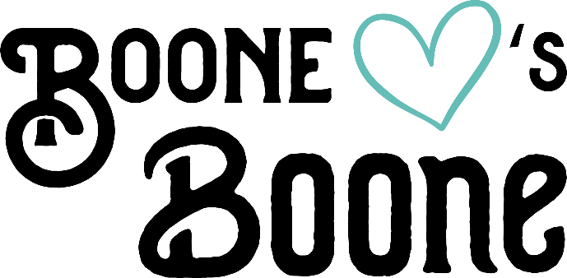

<https://apnews.com/article/hurricane-helene-north-carolina-boone-tourism-aac13c92e403bb119f2f235e81dcdc5b>

For media inquiries, please contact:

Allyson Gutwein

Discover Boone County

PO Box 644, Lebanon, IN 46052

allyson@discoverboonecounty.com

765-484-8572