**VILLAGE OF** **GARLAND**

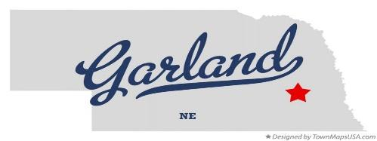

**villageofgarland@gmail.com P.O. BOX 105 (402) 499-9144 www.villageofgarland.org GARLAND, NEBRASKA 68360**

April 12, 2025

Village water consumer;

Village of Garland Water/Wastewater

The Village is required to inform its water consumers annually of 2 informational documents:

1. The 2023 Annual Water Quality Report

2. The pamphlet Common Backflow Preventers and Their Use

The Annual Water Quality Report is a document that contains test results from previous years for different contaminants

Common Backflow Preventers and Their Use pamphlet is part of an ongoing educational program to inform our water consumers of public health risks associated with cross connections and backflow into the village's water system.

You can request a copy of these documents from Garlands Village Clerk Wayne Regnier @ [villageofgarland@gmail.com](mailto:villageofgarland@gmail.com) or call 402-499-9144. Or they are available online at: Village of Garland web page: <https://villageofgarland.org/home>

Thank you

Wayne Regnier (402)499-9144 Village Clerk & Water/Wastewater Operator

DATE_____________ April 12, 2025________________________