|  |
| --- |
| Central  police department  the central police department is looking for  dedicated candidates to join our team who are  wanting to serve and protect our community.  Minimum Requirements:  * High school diploma or GED  * Valid SC driver`s license  * No felony convictions  * At least 21 years of age  * Certified Police Officer  * 2 years of Law Enforcement Experience  Town of Central Police Department  1067 W. Main St.  Central, SC 29630  (864) 639-4020 |

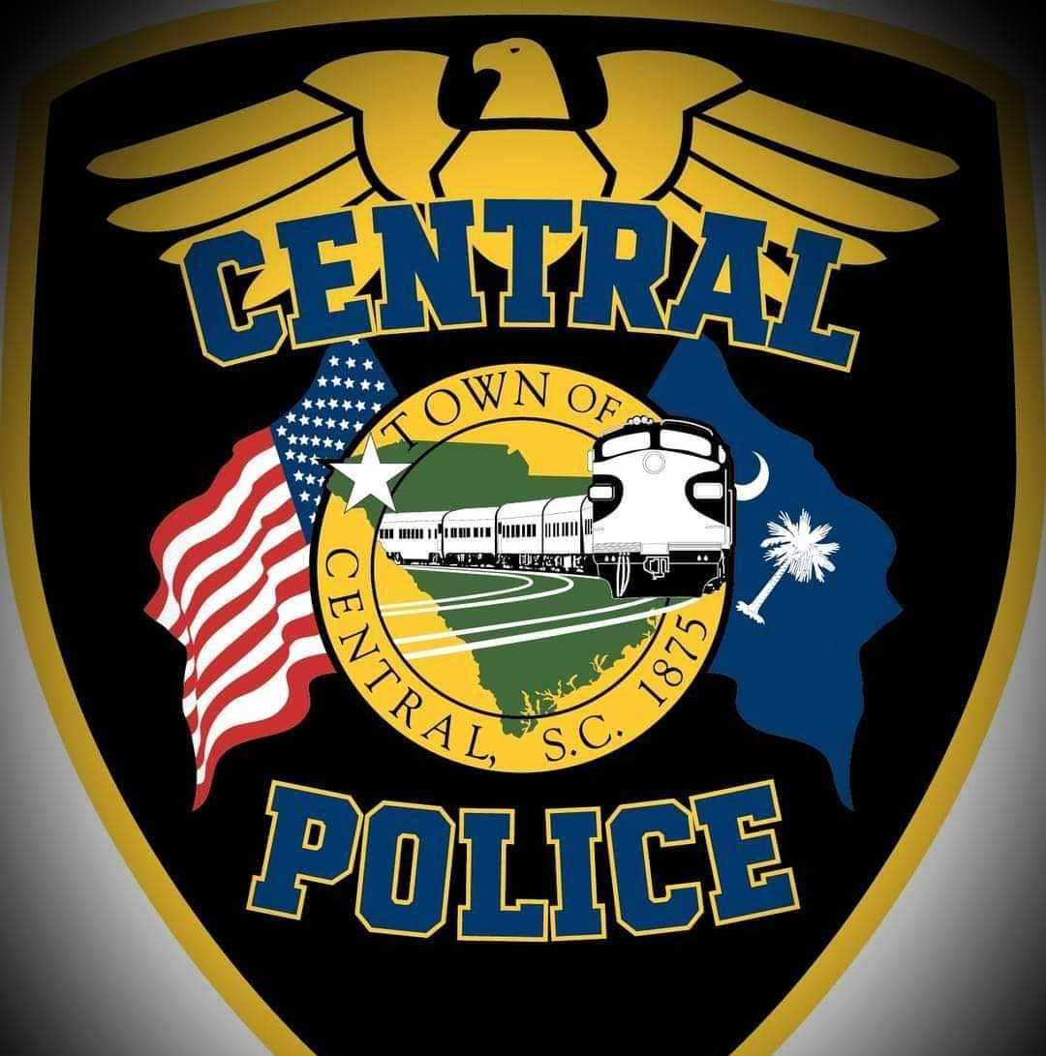

**Patrol**

**Sergeant/Training**

**Coordinator**

**Salary**

**$43,592 - $51,183**

**(starting salary per year)**

**(Dependant on Experience)**

To Include Departmental Fully

Paid Employee Insurance

Benefits Package

&

Spouse/Family Coverage Option

* Paid Sick Leave

* Paid Annual Leave

* 9 Paid Holidays

* Gym Membership Discount

* Take Home Patrol Vehicle

* Retirement Benefits

* Outer Carrier Body Armor

* Up to Date Equipment