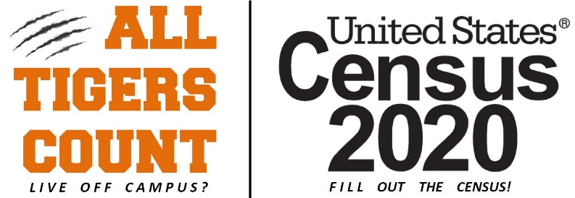
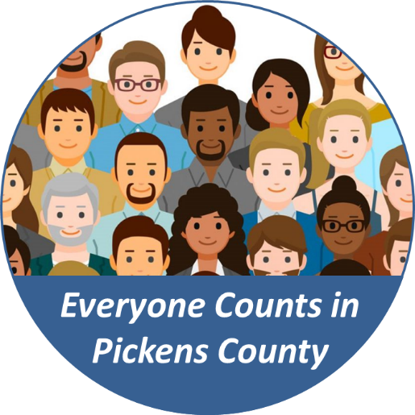

Pickens County, SC Response Rates
As of 3pm EST on 5/3/2020

Liberty has the largest increase with 2.6 points making a charge on Easley!
Easley may cross the 60% mark soon!

You good with your iPhone? Want to win $30,000? See below
% of households who have completed the 2020 Census | Current Day % | Previous Update %  4/30/2020
USA | 55.6% | 54.6%
South Carolina | 51.1% | 49.2%
Pickens County | 53.1% | 50.7%
Central | 40.3% | 38.8%
Clemson | 45.5% | 44.5%
Easley | 58.5% | 57.3%
Liberty | 57.9% | 55.3%
Norris | 43.9% | 41.3%
Pickens | 50.8% | 48.9%
Six Mile | 53.7% | 52.1%

Please help us spread the word about the 2020 Census during the month of May!!
- Post content on social media to show your commitment to responding to the 2020 Census. Take a look at the Resource Guide — with social media graphics, video scripts, and example posts.
- Share and like posts from our Facebook, Twitter, and Instagram accounts with stakeholders, friends and family for the most current information on 2020 Census operations.
- Visit the 2020 Census Social Hub for customizable graphics to share your support for a complete and accurate count.
- Enter the Get Out the Count Video Prize Challenge. The deadline is May 7, 2020. Win $30,000
- Check out the Response Rate Map and Rankings Dashboard to see how your hometown and where you used to live is doing; encourage your family and friends to participate. It’s a great way to track the progress of the nation’s self-response. The map is updated every evening to reflect the self-response rate of the entire country.

